**CSS 🡪 Cascading Style Sheets**

**Anatomy of CSS Rule**

**3 ways of creating the styles**



Internal styles Inline styles External styles



Internal styles 🡪 using <style> element inside the <head> section



Inline styles 🡪 using style attribute inside HTML elements



External styles 🡪 using <link> used to link an external CSS file



**Internal Styles**

What-ever rules are given in this paragraph   
p {

}  
will be applied to every single paragraph tag in the entire HTML page.

Semicolon is not required, but using ; is the best practice.

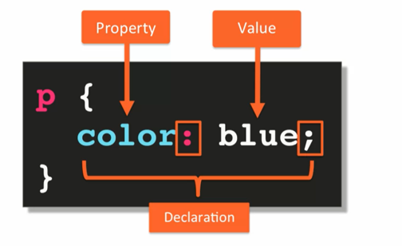



Style sheet

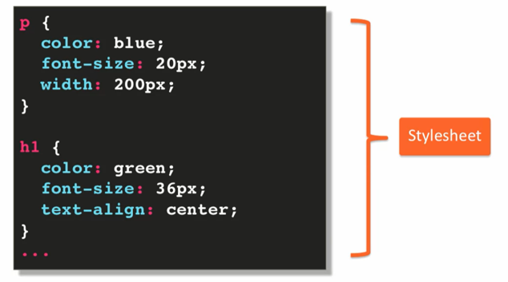

An empty style sheet is also a style sheet. But no point of using them.

We can do the CSS part separately and HTML part separately and can link each-other using <link

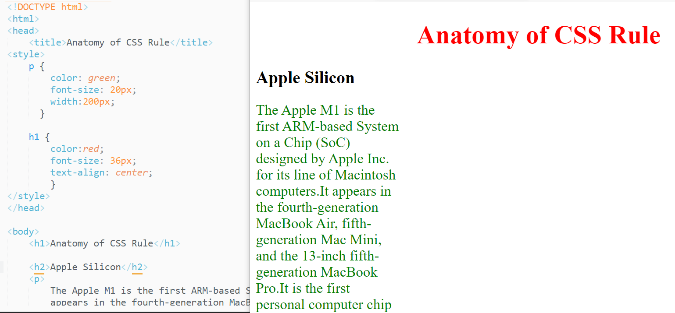

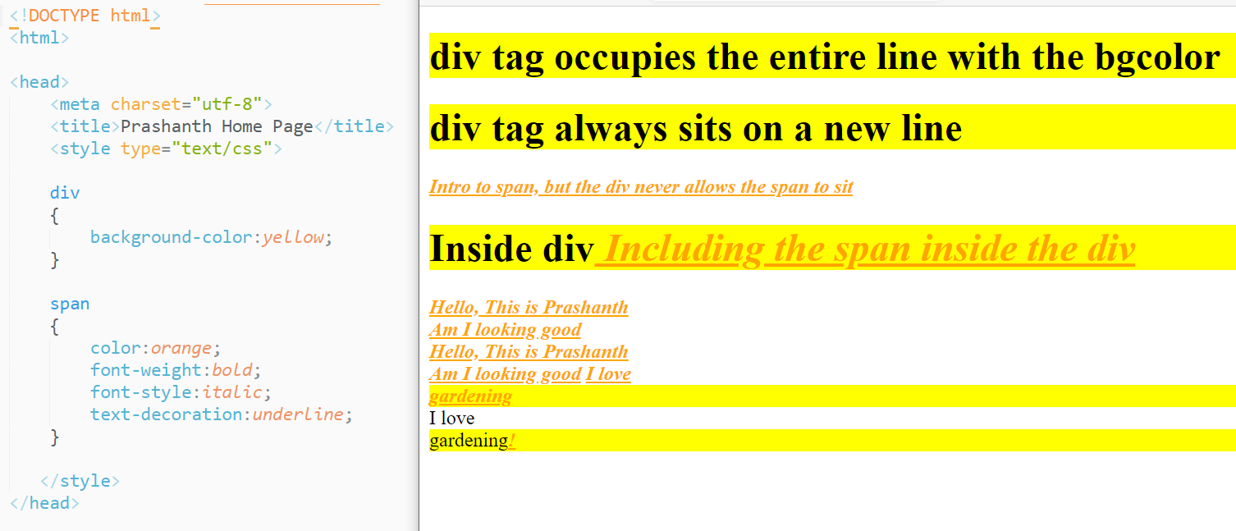

**External Styles**

**Linking the HTML file with CSS**

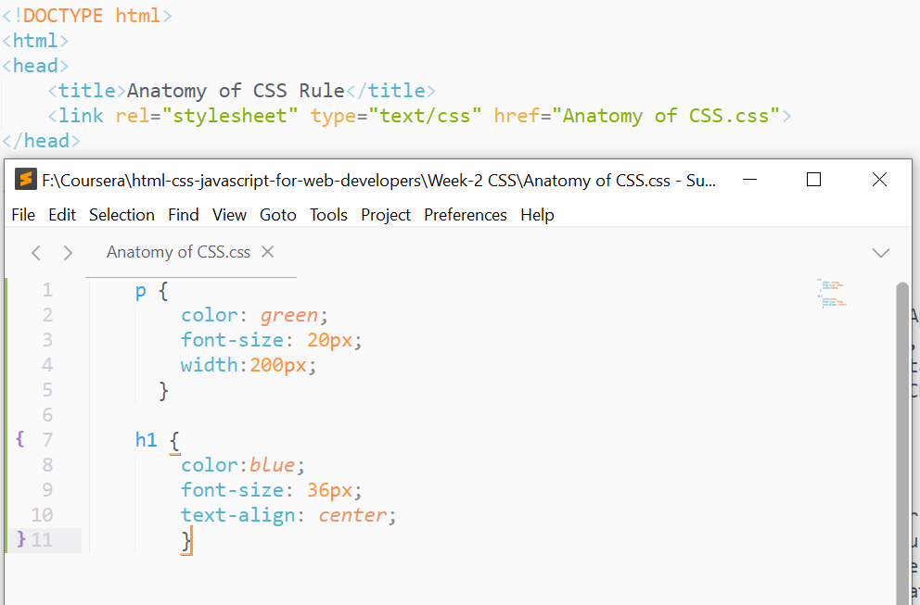



Make sure that both the files should be in the same directory.

**What is Cascading??**  
Cascading means it always the selector which is at the end

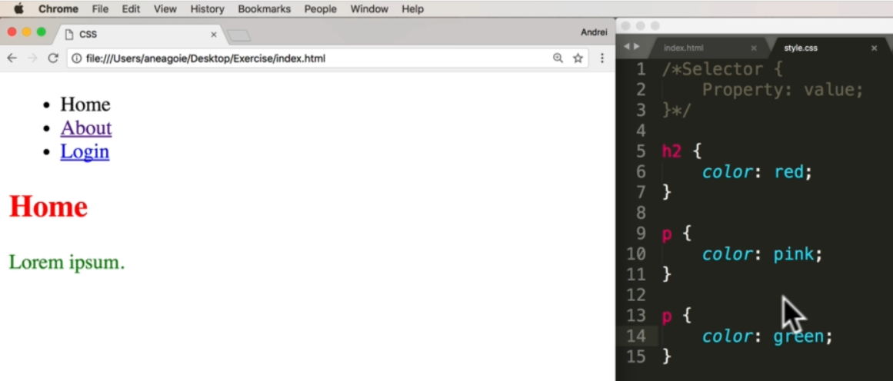

The color of the paragraph was set to pink, but at the end the color of the paragraph is green. So CSS takes the selector which is at the end.

Adding the css styles even directly in the browser using Developer tools

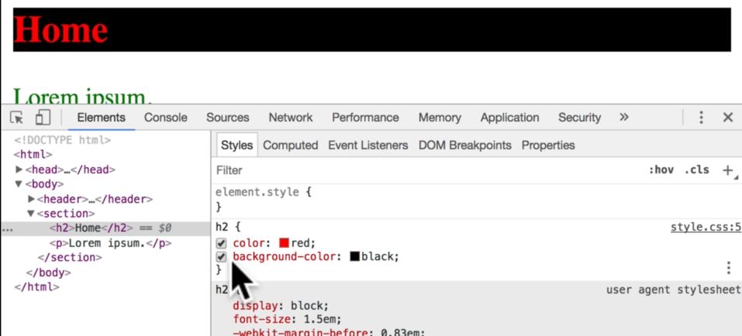

Added background color to the heading.

**Inline Styles**  
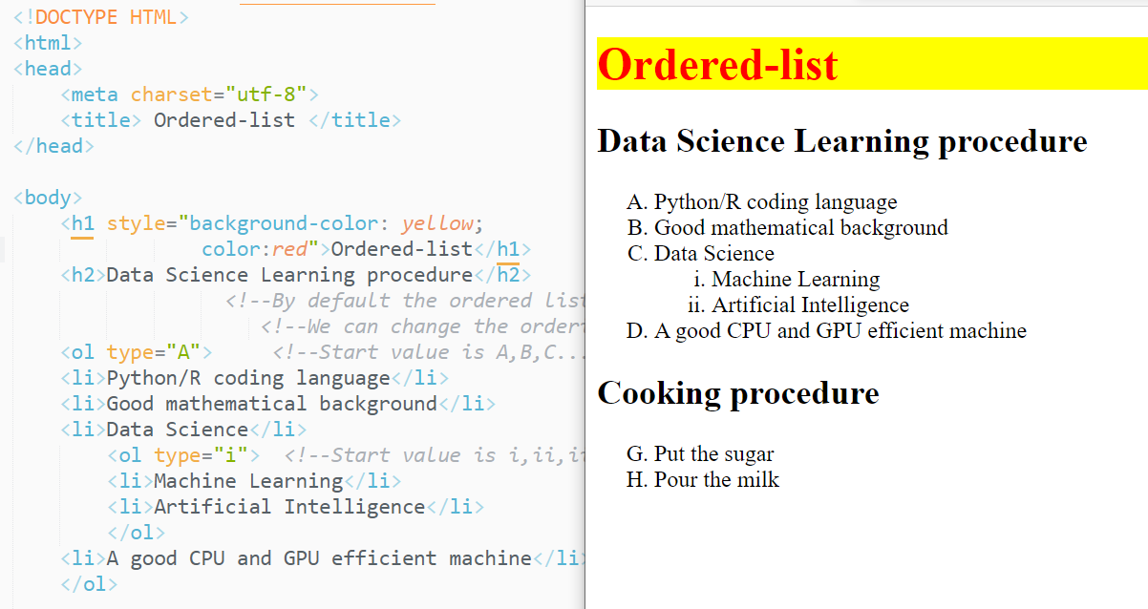



**Quiz question:**

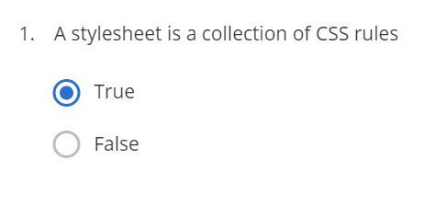

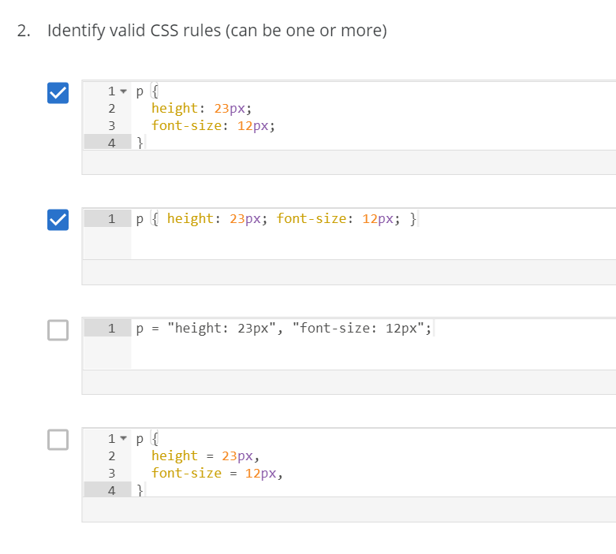

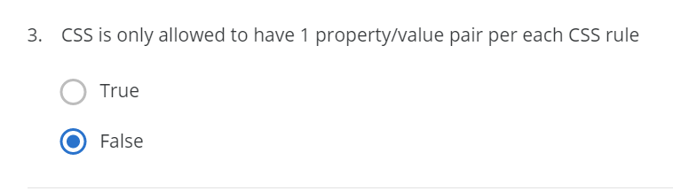

**Element, class and ID selector**

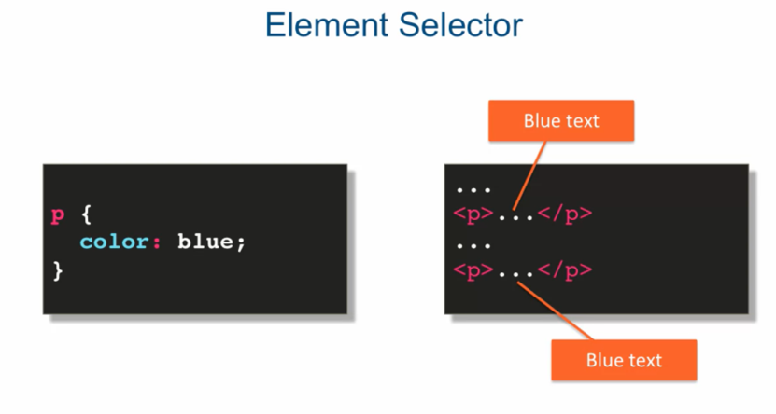

What-ever the text include in <p> will be in blue color.  
The text in <div> and <span> will not be blue in color,

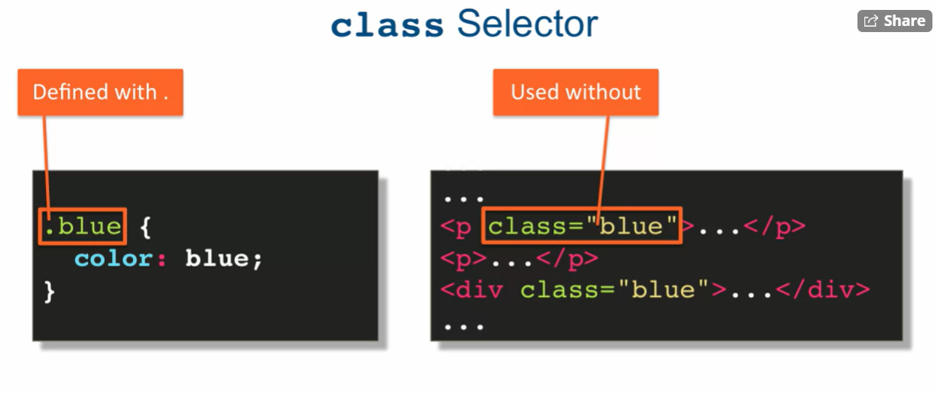

In class selector, the color blue is defined with .blue and while using it is used in the attribute as class=”blue”

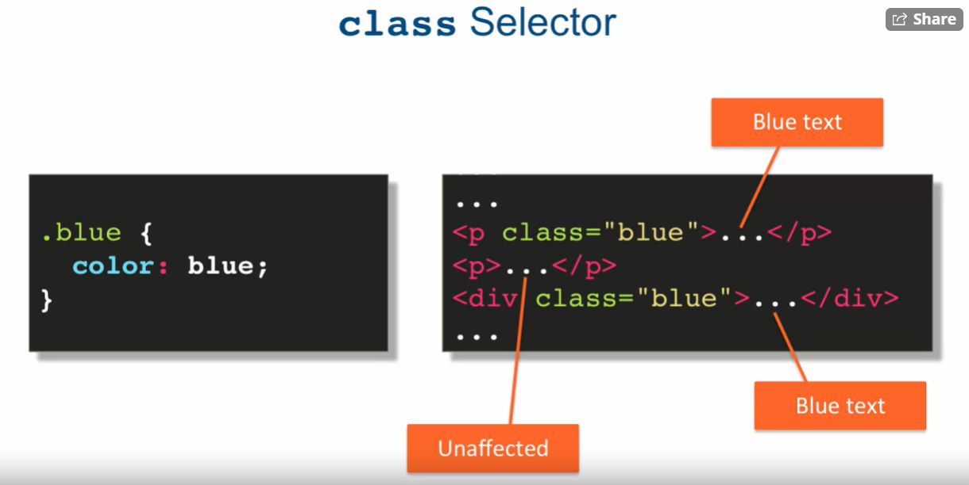

The place where we didn’t mention the class will be unaffected.

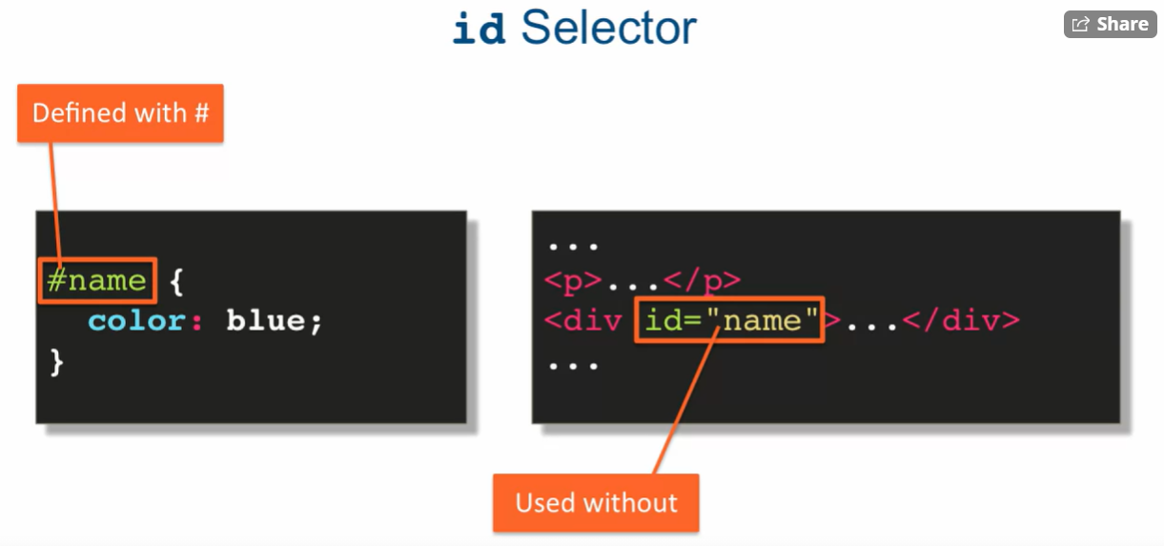

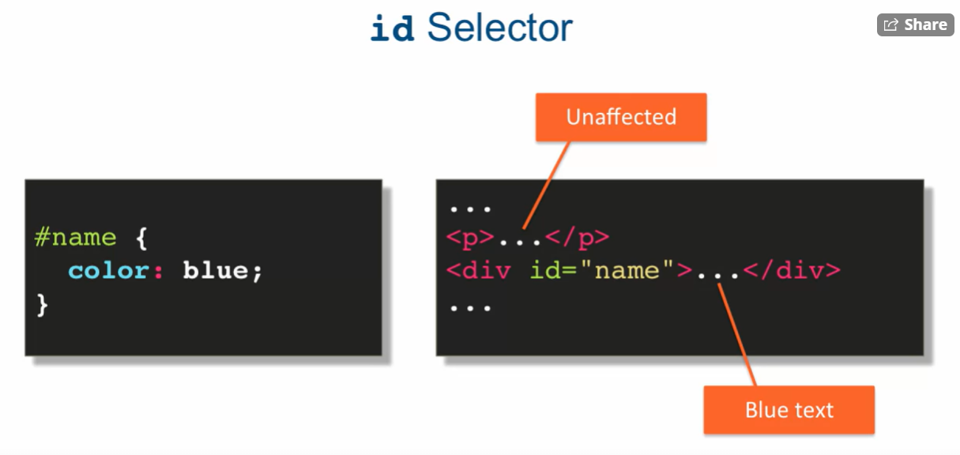

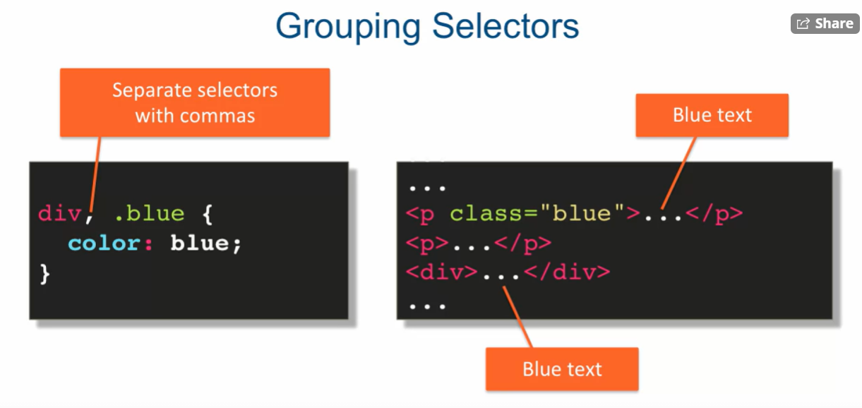

div and color also uses it.

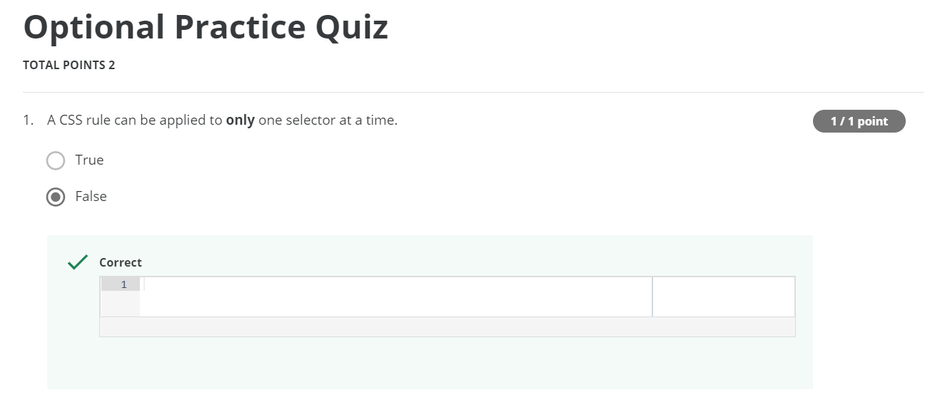

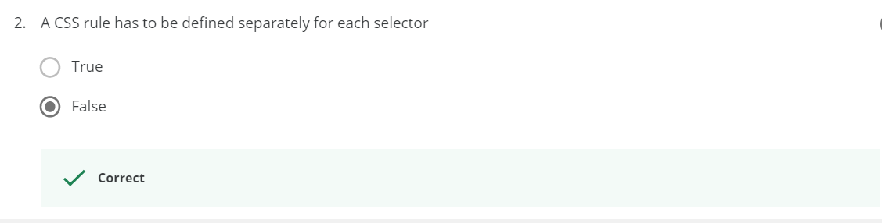

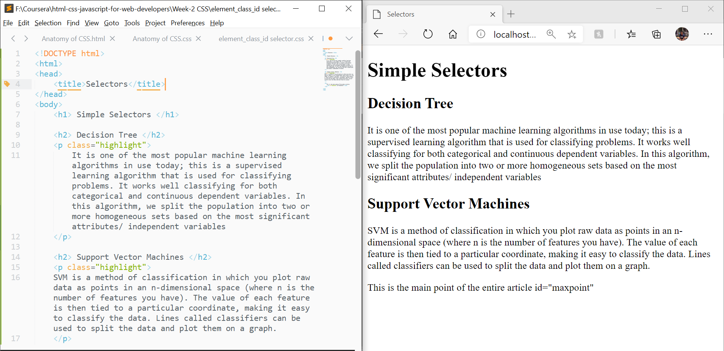  
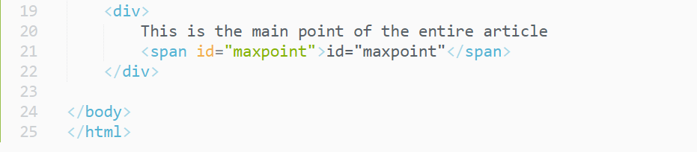

element selector

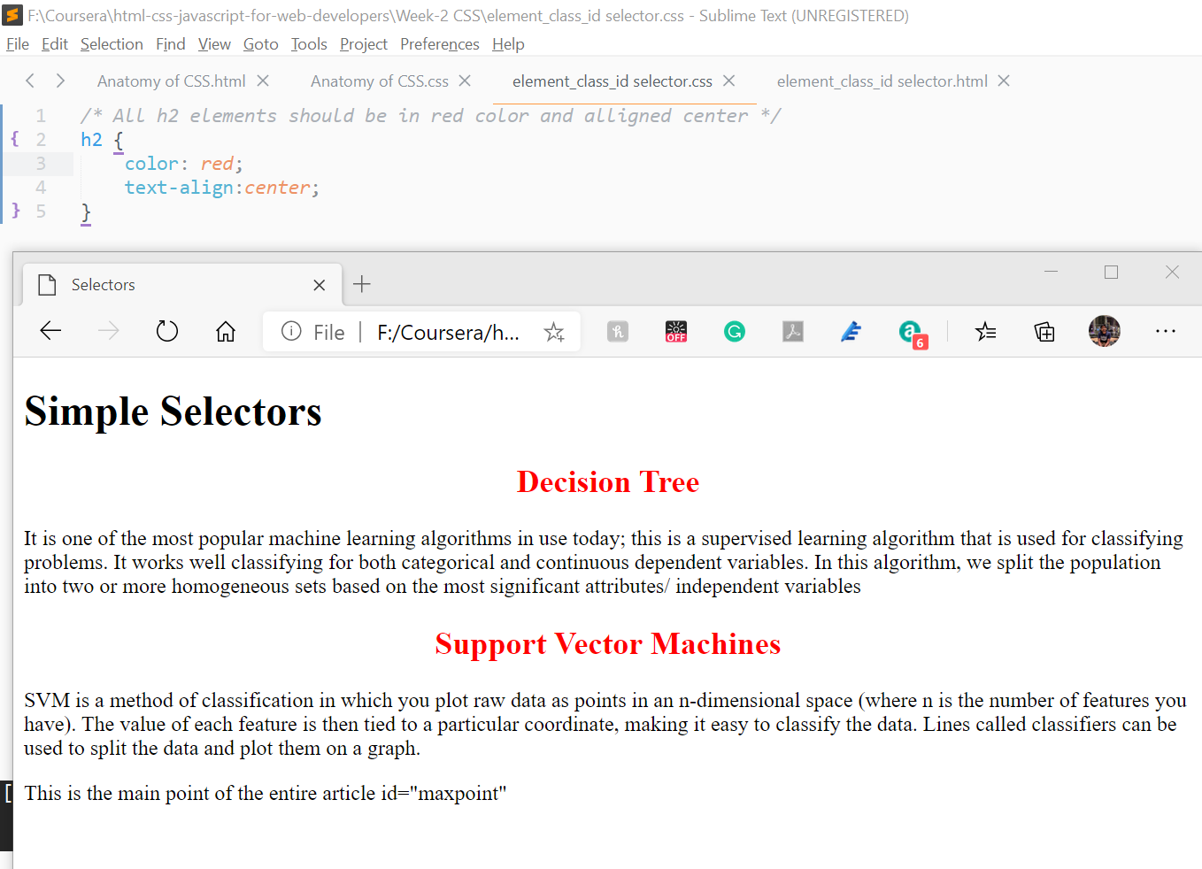



Class selector

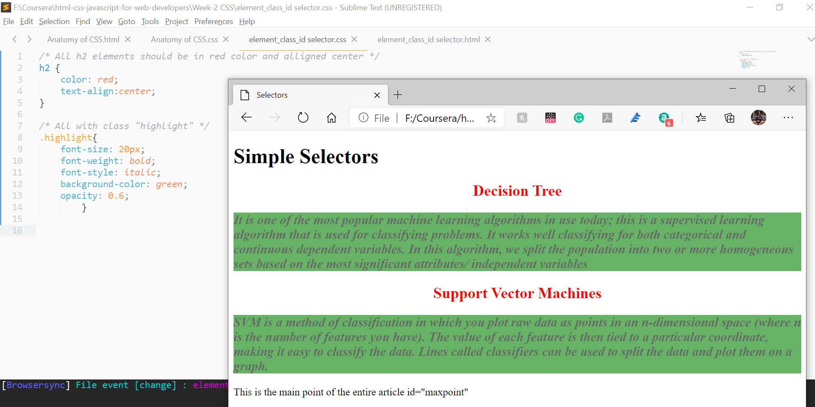



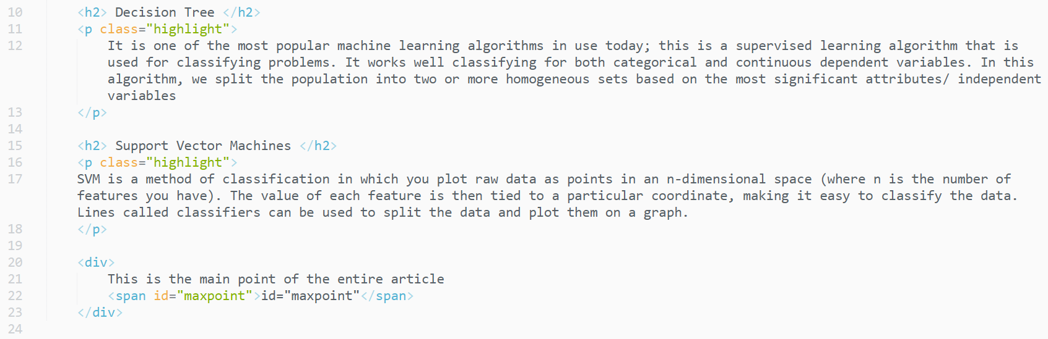



id selector

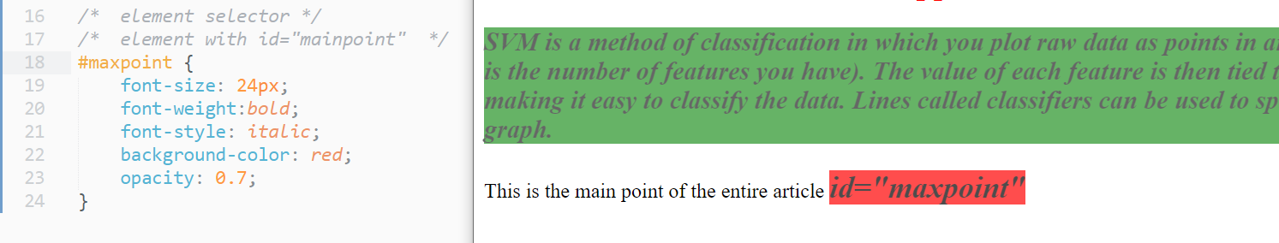

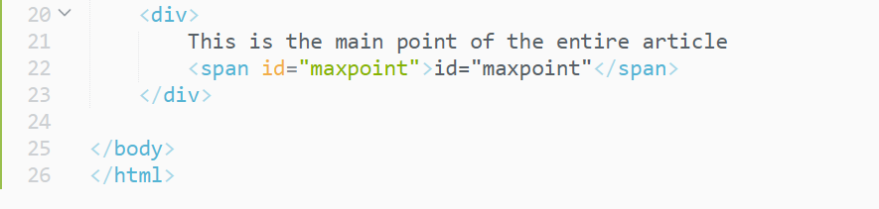



group selector

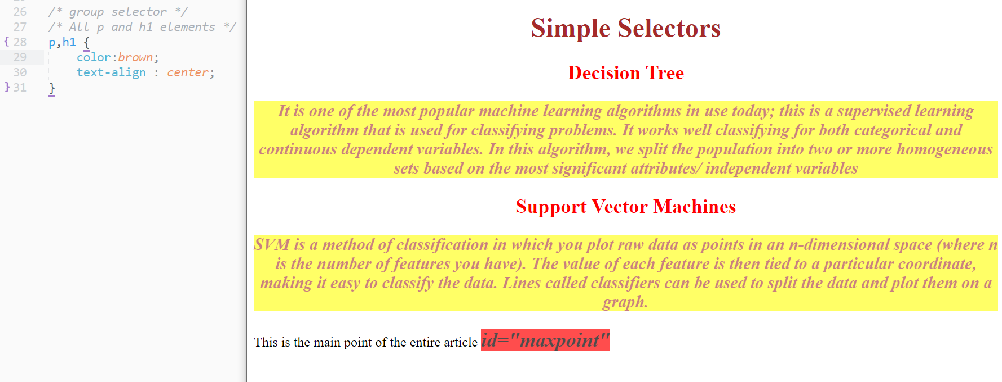

Finally, before CSS

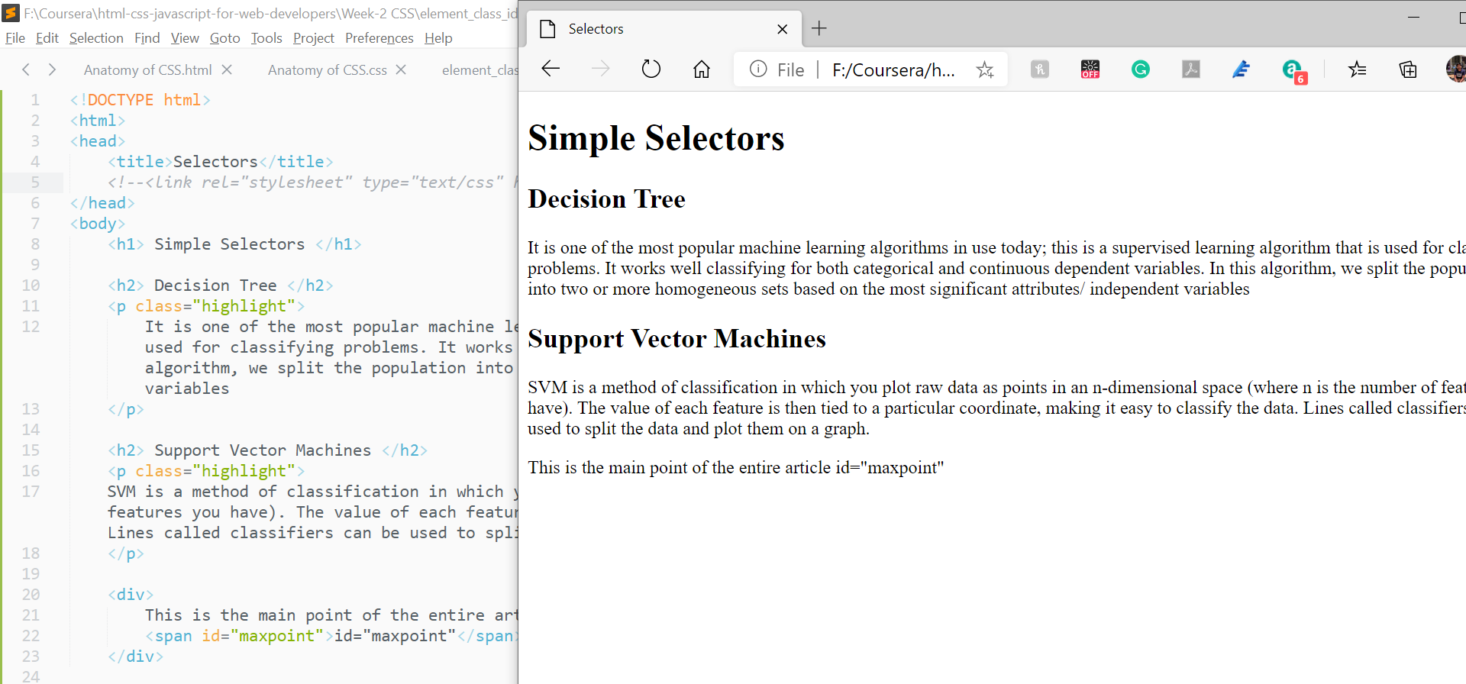

After CSSs

